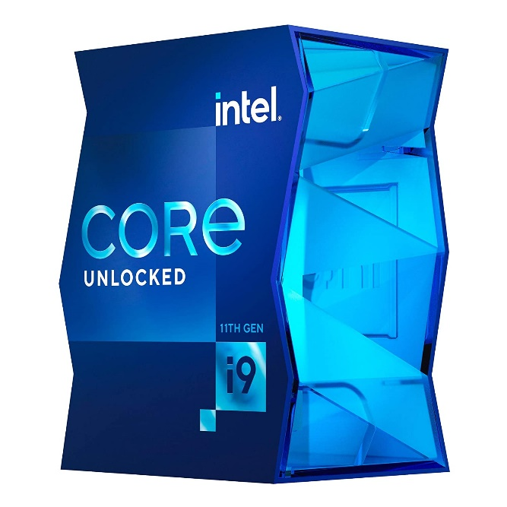

Inner

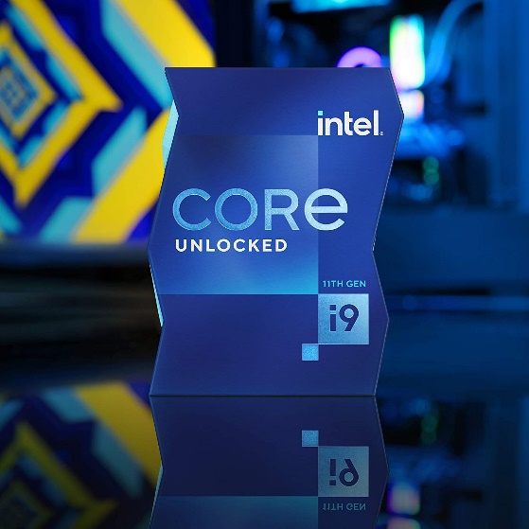

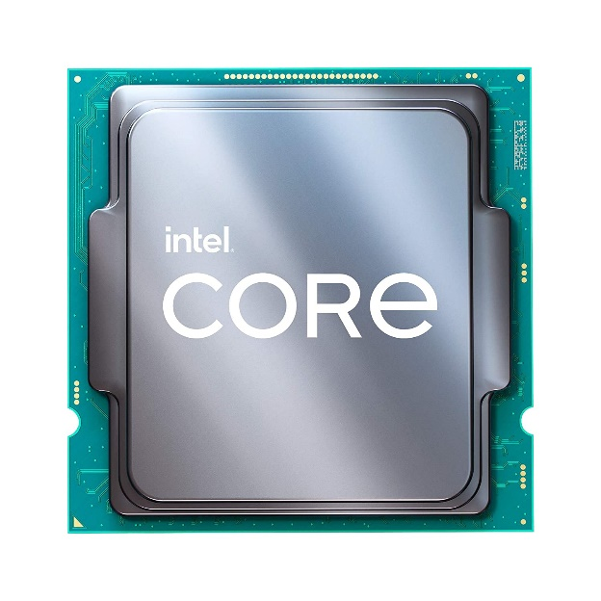

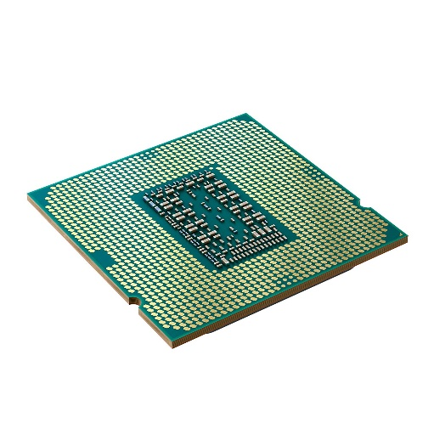

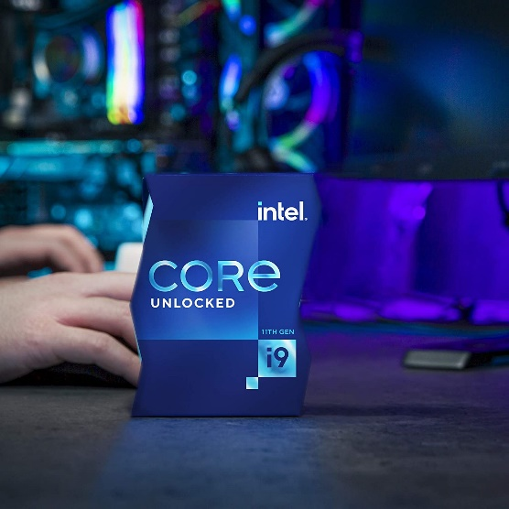

Intel Core i9-11900K Desktop Processor 8 Cores up to 5.3 GHz Unlocked LGA1200 (Intel 500 Series & Select 400 Series Chipset) 125W

-33% ₹46,980.00

M.R.P.: ₹70,000.00

|  |  |
| --- | --- |
| Brand | Intel |
| CPU Manufacturer | Intel |
| CPU Model | Core i9-11900K |
| CPU Speed | 5.3 GHz |
| CPU Socket | LGA 1200 |

**About this item**

* The processor features Socket LGA-1200 socket for installation on the PCB
* 16 MB of L3 cache rapidly retrieves the most used data available to improve system performance
* 14 nm design offers great efficiency for computing, delivers nimble processing with balanced cost, performance, and power
* To boost graphics and visual quality, the chipset has a built in Intel UHD Graphics 750 controller. Supports up to 3 monitors.